**PROBABILITY AND STATISTICS**

**(UCS410)**

**LAB ASSIGNMENT 4**

**NAME : TARUSHI GERA**

**ROLL NUMBER : 102103391**

Q1.

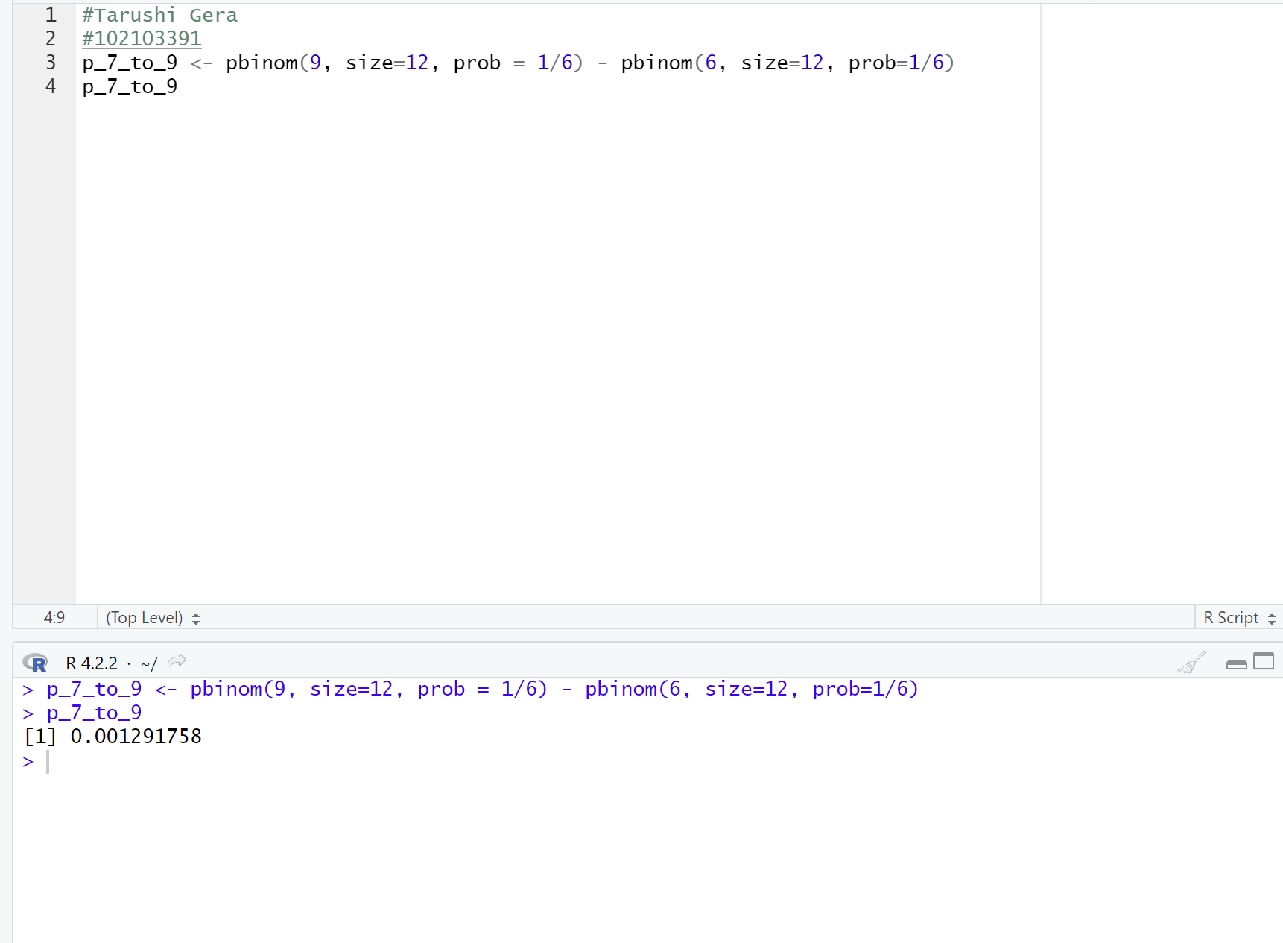

Q3.

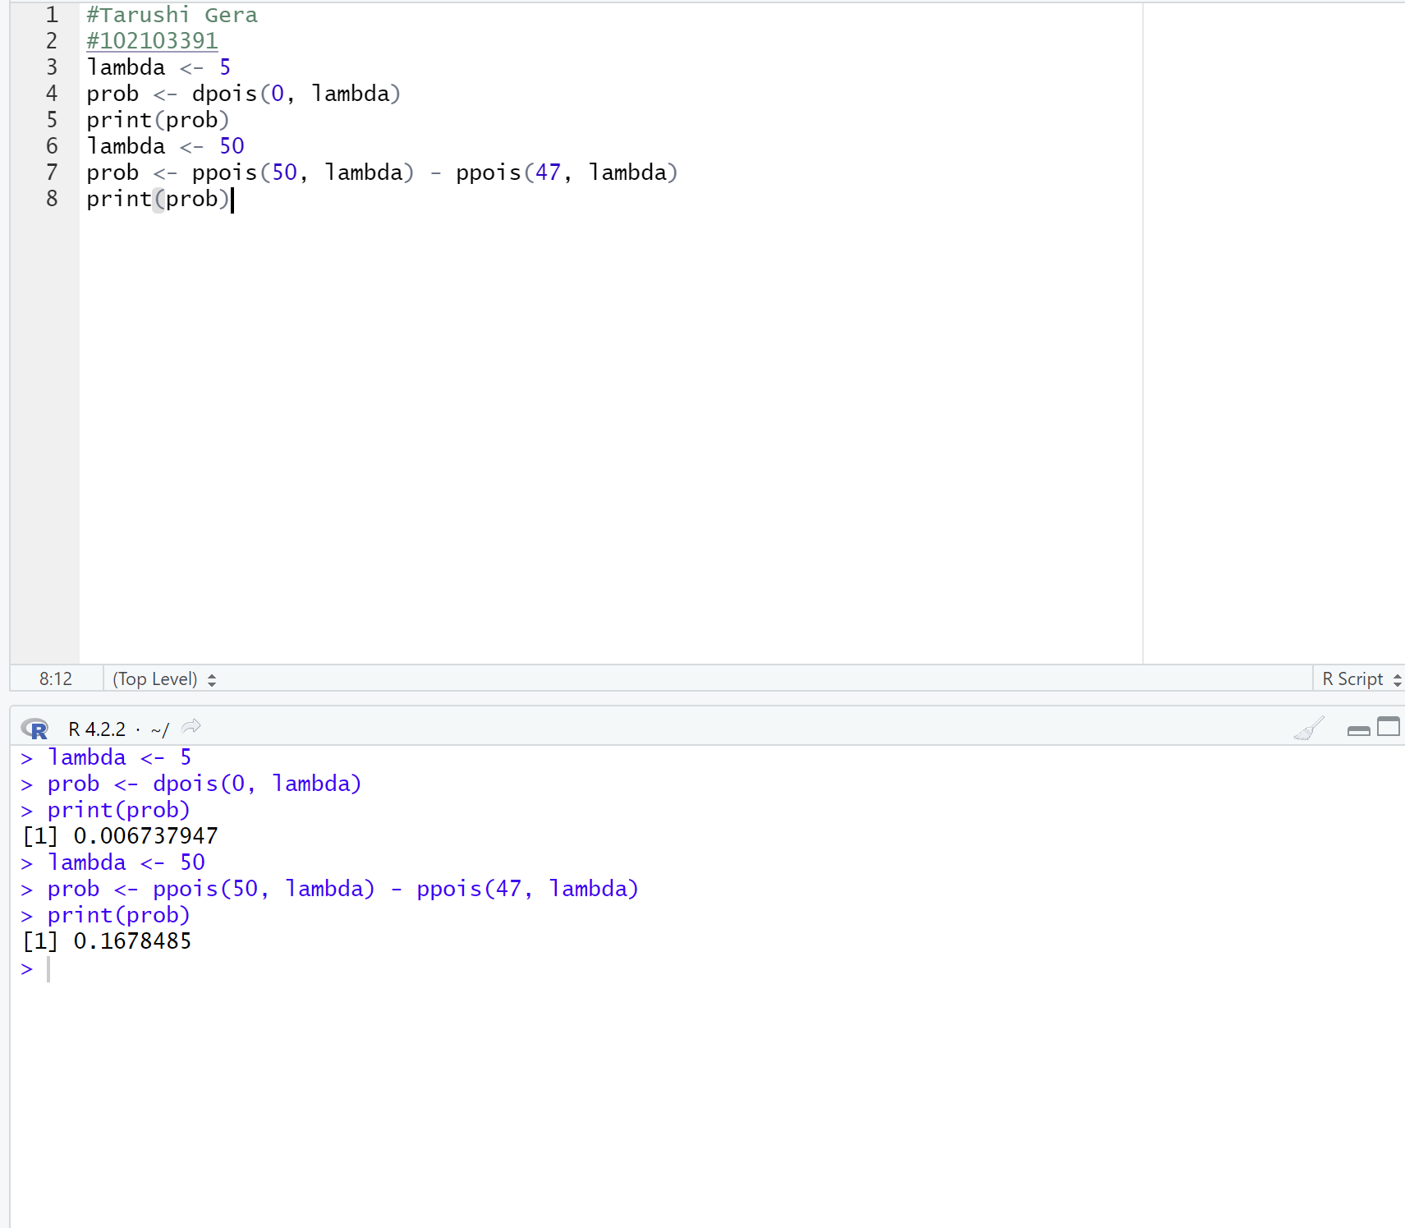

Q4.

